**ROCK PI 3A Rockchip RK3568**

Rock 3 is the latest generation of SBC based on rockchip RK3568. It adopts a traditional appearance and can run Android or some Linux distributions

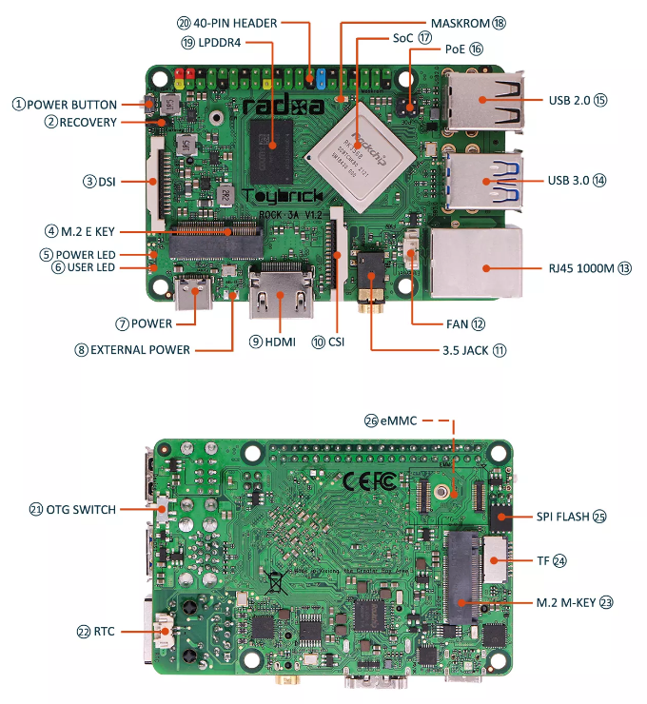

* Processor: Rockchip RK3568
* RAM: 2GB, 4GB or 8GB of LPDDR4-3200 memory (DRAM controller frequency up to 1560 MHz)
* Storage: Pluggable eMMC module, M.2 key for PCIe 3.0 x2 NVMe SSD (on the bottom), microSD card reader
* USB-C: 1 x USB-C for power delivery
* USB-A Ports: 2 x USB 3.0 (1 x OTG and 1 x Host) and 2 x USB 2.0
* Connectivity: Gigabit Ethernet with PoE support and M.2 E key for PCIe 2.0 x1/SDIO/UART with support for WiFi cards
* Display: HDMI 2.0 and MIPI DSI
* Other connectors: 40-pin GPIO header and MIPI-CSI camera connector
* Dimensions: 85mm x 54mm (3.3″ x 2.1″)
* $55.00

